Procedure for setup PecChart Template
1. Start the PecChart by click on the PecChart icon in windows start menu.
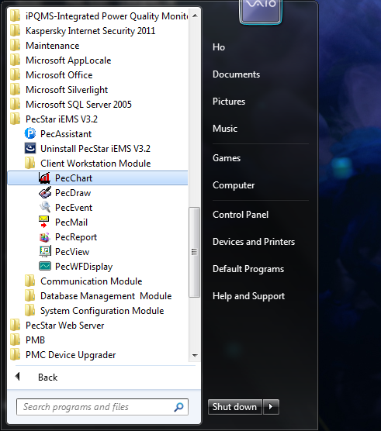
2. The following windows will appear. This is the PecChart user interface.
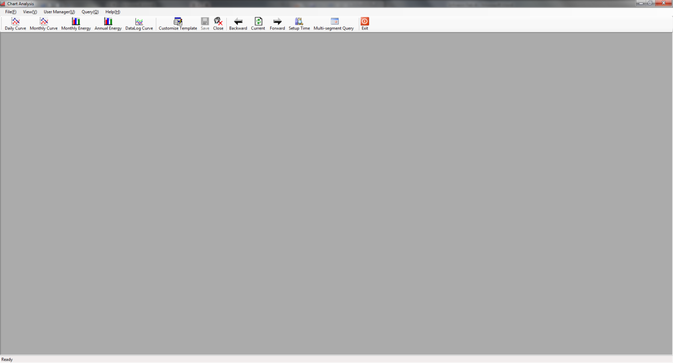
3. For create PecChart template, please log in the software with user which have authority level of "Change User Diagram". If only view the Chart no need to login.
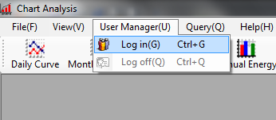
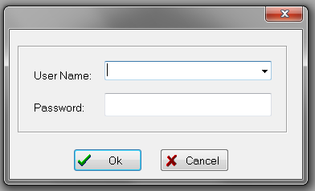
4. Select the type of Chart you want to use, in this example Daily Curve is selected.
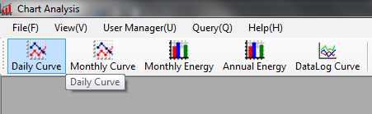

5. After click on the Daily Curve the following screen will appear. You will see the screen is separate in two parts. On the Left is the setup area and the right is display area.
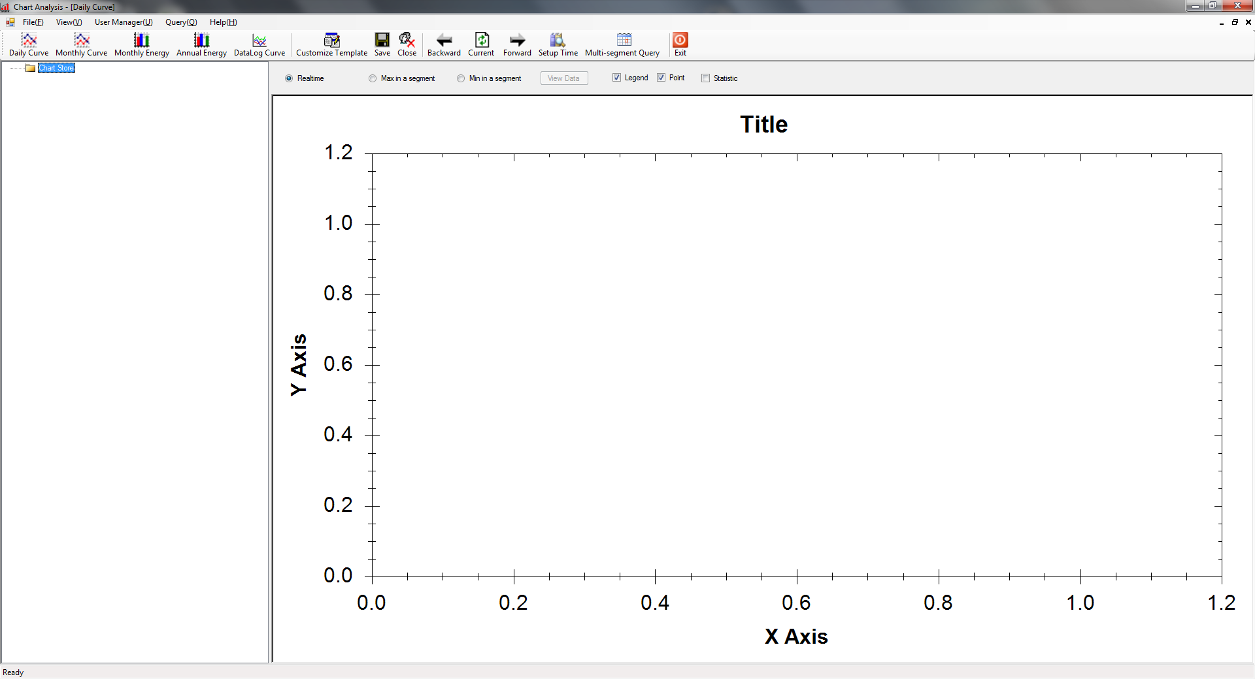
6. Right click on the setup area; you will see the following popup menu. In the menu there are four selections
A. New Chart Group - Open group for more easily manage the Chart.
B. New Chart - Adding a logged parameter that you want to see in the Chart.
C. Modify Source - Modify the added chart; include the parameter and the chart color.
D. Delete Source - Delete added chart.
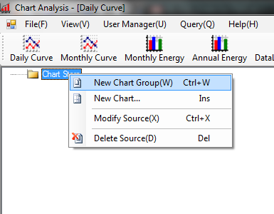
7. Create a new group and add a new chart under this group.
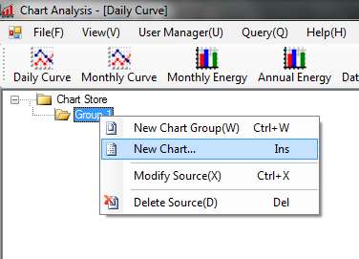
8. Select the parameter you want to read and define the color for this chart.
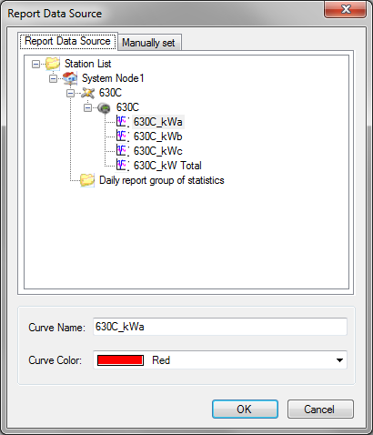

9. after configuration will see a new added chat list under the group that you selected.
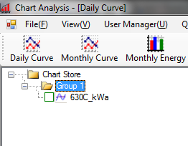
10. Save the template for complete the chart configuration.
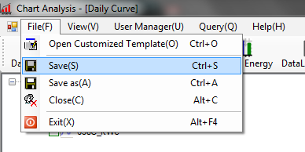

11. Click Save the following windows will appear and then press "OK" to save.
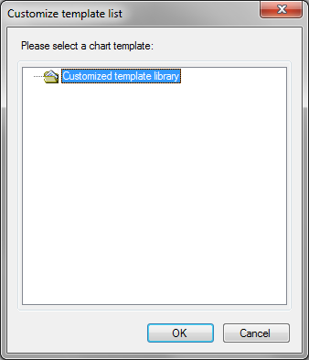
11. Input a name for this template and press ok to finish the setup.
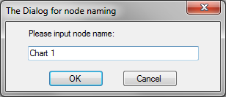
12. A confirmation windows will appear, if you save the template successfully.
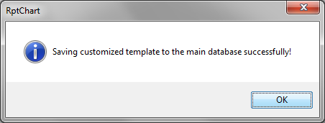

How to use the customized template
1. Select File at the tools bar and click Open Customized Template.
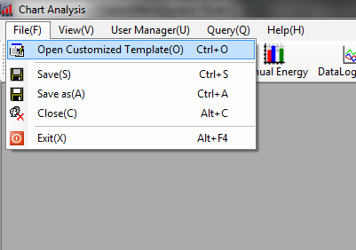
2. The Customize template list will appear for selecting the template.
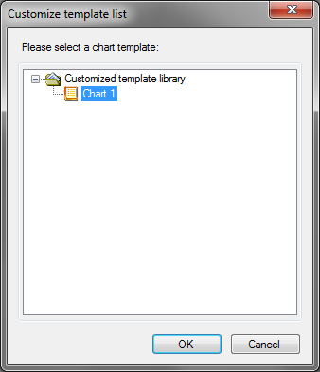

3. The selected template will appear now you can chose parameter that you want to show in chart.
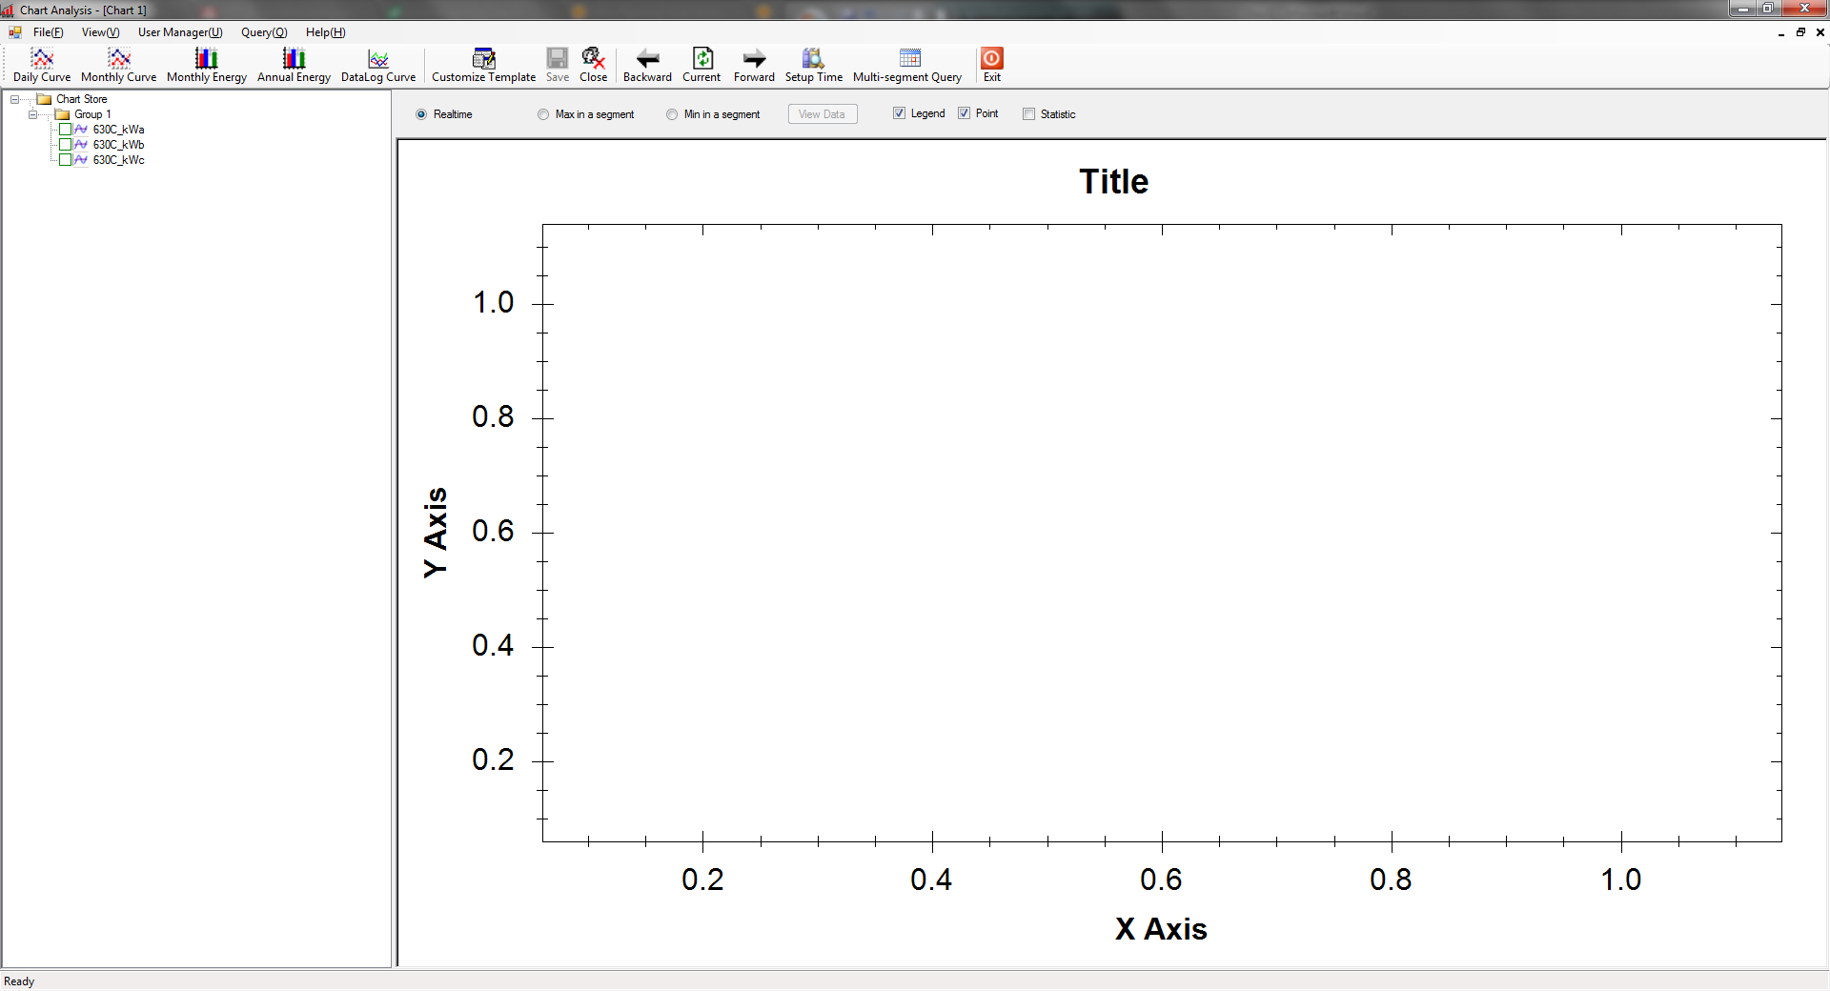
4. Click the check box in fonrt of the parameter
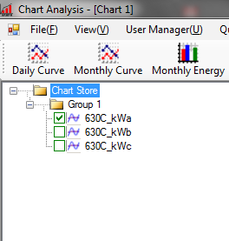

5. The selected chart will appear in the display area.
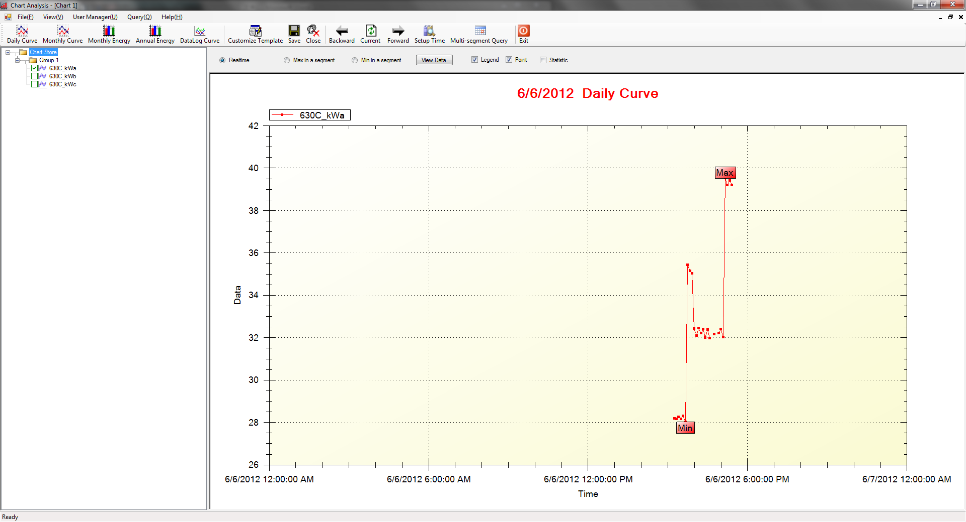
6. You can enlarge the chart by drag an outline around the area you want to enlarge
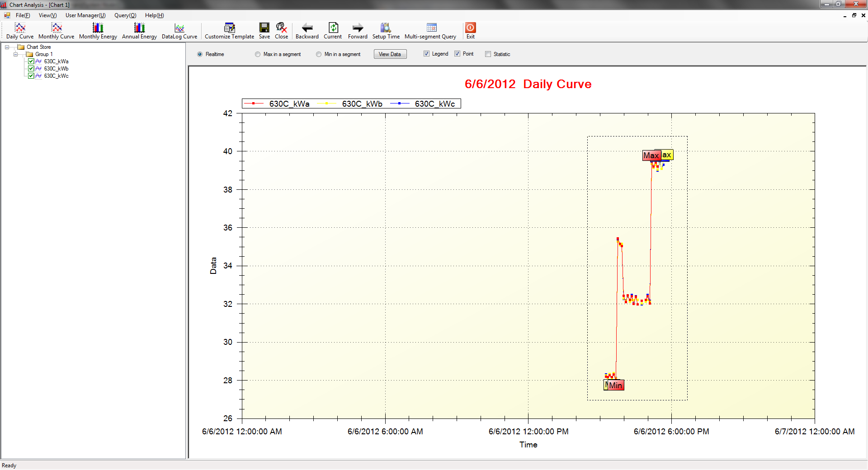

7. The enlarge result is shown as below
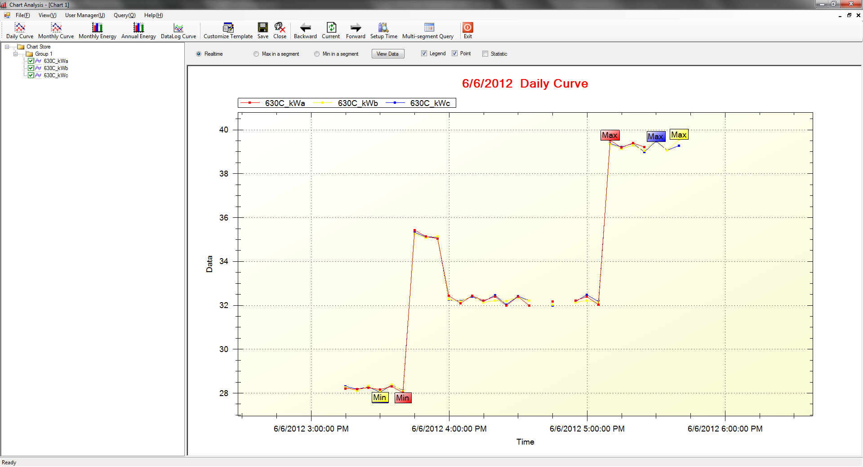
8. It also support raw data export function, click the "View Data" button.
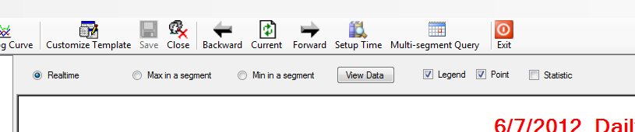

9. Double click the parameter that you want to export.
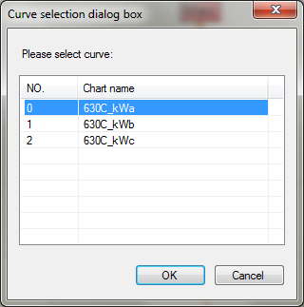
10. Press "Export Data" to save the data in excels.
